LOCAL PENSIONS PARTNERSHIP INVESTMENTS LIMITED
Lancashire County Pension Fund
Pension Fund Committee | 8 June 2018
Responsible Investment Report

Title of Paper | Quarterly Report on Responsible Investment (2018 Q1)
Lead Officer: | Frances Deakin  Responsible Investment Manager  Local Pensions Partnership Investments Ltd  frances.deakin@localpensionspartnership.org.uk
Appendices | None

- Executive Summary

This report provides members of the Pension Fund Committee of Lancashire County Pension Fund (LCPF) with a quarterly update on Responsible Investment (RI) matters.

- Introduction

The Fund's approach to RI has been articulated within an Investment Strategy Statement (ISS) which confirms that the objective of RI is to decrease investor risk, improve risk-adjusted returns and assist the Fund's adherence to the UK Stewardship Code. The Fund’s ISS is due to be updated to reference the Responsible Investment Policy agreed by the Pension Fund Committee at its last meeting in March 2018.

The Fund's preferred approach to RI encompasses four main areas of activity:
- Voting Globally
- Engagement through Partnerships
- Shareholder Litigation
- Active Investing

Responsibility for the practical implementation of the Fund's approach to RI is devolved to Local Pensions Partnership Investments Ltd (LPP I) as LCPF's provider of investment management services. The report which follows provides the committee with an update on RI activity during the period 1st January to 31st March 2018 plus insight on current and emerging issues.

- Voting Globally

Through its investment in the LPP I Global Equities Fund (GEF) LCPF owns units in a pooled fund which invests in listed companies globally. Investors in the GEF delegate the control and exercise of shareholder voting to LPP I. This reflects that clients who hold units in the GEF are beneficial owners in common but do not directly own underlying securities.

LPP I exercise shareholder voting rights for the GEF centrally rather than delegating voting to individual asset managers and take account of voting recommendations received from an external provider of proxy voting and governance research (ISS) in accordance a Sustainability Voting Policy designed to ensure the consideration of ESG factors within analysis. LPP I review voting recommendations and take the final decision on all voting.

In the first quarter of 2018 shareholder voting headlines for the GEF were as follows:

LPP Global Equities Fund (GEF)

Total company meetings taking place | 54
Total resolutions  (management and shareholder proposals) | 671
Total company proposals in the period | 649
Total shareholder proposals in the period | 22

Company Proposals
Voting was in line with Management recommendations | 615 | 95%
Voting was against Management recommendations | 34 | 5%

Shareholder Proposals
Shareholder proposals supported by LPP I | 10 | 45%
Votes against shareholder proposals | 12 | 55%

The table below summarises resolutions by type and indicates the subject of shareholder resolutions seen in Q1.

Resolutions by Type |  | Proposals | Examples
M | Antitakeover Related | 2
M | Capitalization | 38
M | Director Related | 361 | Sodexo/Starbucks
M | Non-Salary Compensation | 61 | Sodexo
M | Reorg. and Mergers | 17
M | Routine/Business | 170
SH | Corp Governance | 1 | Costco
SH | Director Related | 11
SH | Health/Environmental | 1 | Starbucks
SH | Other/misc. | 3 | Starbucks
SH | Routine/Business | 5
SH | Social Proposal | 1 | Costco
Total |  | 671

LPP voted against management resolutions in 34 instances.
At Sodexo (French food services and facilities management company) LPP opposed management on 7 resolutions including:
- the re-election of 3 directors due to a lack of sufficient Board independence
- the Remuneration Policy for the outgoing CEO /the Remuneration Policy for the incoming CEO due to the lack of information on certain points and the absence of cap on exceptional remuneration
- the compensation of the CEO due to lack of information on certain points
Meeting results confirm that all management resolutions passed with a large majority.

At Svenska Cellulosa AB (Nordic Forest Products) LPP opposed management on 4 resolutions including:
- the re-election of Directors holding multiple other chairmanships/directorships/non-executive directorships.
- The election of the Board Chairman for excessive other commitments
- the remuneration policy and terms of employment for Executive Management due to a lack of disclosure concerning the company's long-term, cash-based variable remuneration plan.
Meeting results confirm that all management resolutions passed with a large majority.

LPP supported shareholder proposals in 10 instances across 7 company AGMs.
The resolutions gaining support covered familiar territory in seeking to tackle governance issues and increase the potential for shareholder influence.

Resolutions seeking to improve proxy access (the rights of shareholders to nominate directors) were as follows:
Company | Sector | Result | Pass/Fail
Becton, Dickinson and Co | American global medical technology company | 27.6%  support | Fail
Apple Inc. | American multinational technology company | 32.19%  support | Fail

Resolutions seeking to amend byelaws and articles of incorporation (to strengthen SH rights and governance practices) were as follows:
Company / Issue | Sector | Result | Pass/Fail
Deere & Co / establish a SH right to call Special Meetings | American agricultural/industrial machinery company | 28.96% support | Fail
KB Financial Group / enshrine a recent byelaw change on the composition of the Nomination Committee within the articles of incorporation | Korean financial services company | Results are not published | Unknown

Additionally, LPP supported a shareholder proposal at Costco Wholesale Corp. (American operator of discount warehouse stores) to replace the company’s current supermajority vote provisions with simple majority voting. The Resolution passed with 86% support.

There was only one shareholder resolution on an environmental theme in Q1 and this was at Starbucks where LPP supported 3 shareholder resolutions in total. Details of these resolutions and the AGM results are shown below:

Resolution | Detail | Result | % Support
Report on sustainable packaging | Asking the company to address a drastic backtrack from an original (2008) goal to have 100% of cups recyclable or reusable by 2015. Currently only 1.4% are reusable and the Co’s revised goal proposes to increase usage to 2.8% by 2022. Other large food service companies have declared aggressive targets for recyclability. | Rejected | 29.16%
Amend Proxy Access Bylaw | Ensure meaningful proxy access to a greater number of shareholders. Remove the current limitation on the number of stockholders that can aggregate their shares to arrive at the 3% required to be eligible to form a nominating group. | Rejected | 32.7%
Produce an Employment and Diversity Report and Report on Diversity Policies | Starbucks does not release comprehensive workforce data or results of diversity initiatives to its shareholders despite saying that it promotes workforce diversity. Lack of disclosure leaves shareholders with inadequate information to determine the company's success in expanding workforce diversity and capturing the potential value creation generated by a highly diverse workforce. | Rejected | 34.74%

Members can view details of voting for all meetings via the LPP website where quarterly reports for the GEF are made publicly available.
https://www.localpensionspartnership.org.uk/what-we-do/investment-management

- Engagement through Partnerships

LPP I regularly participates in collaborations which aim to make progress on commonly held issues by co-ordinating the efforts of multiple investors. Key partners include the Local Authority Pension Fund Forum (LAPFF) the Pensions and Lifetime Savings Association (PLSA) the Principles of Responsible Investment (PRI) the Institutional Investor Group on Climate Change (IIGCC) the LGPS Cross Pool RI Group, and the UK Pension Fund RI Roundtable.

LAPFF

LAPFF has long been LCPF's preferred engagement partner.
The Forum’s AGM and most recent quarterly Business Meeting took place on 28 March 2018 where the Fund was represented by the Chair of the Pension Fund Committee and the Head of Fund.

The AGM encompassed a ballot on proposed amendments to the LAPFF Constitution reflecting changes required to accommodate the membership, representation and participation of LGPS Pools. Results distributed after the meeting show all but one amendment to the constitution was accepted but members voted not to allow pool representatives to chair the LAPFF Executive.

Forum members supported a pragmatic proposal that LAPFF Executive elections should be deferred until after the May local council elections to enable new participants to come forward from the widest possible candidate pool. Member funds have been asked to consider/prepare to put candidates forward as nominees for both officer and elected member roles on the Executive. In particular there is a need for candidates to replace current councillors on the Executive who did not re-stand at the May local elections and will step down from the Executive at the next AGM.

LAPFF Q1 Engagement Report
The LAPFF engagement programme reflects the Forum's assessment of key priorities from across the collective equity holdings of LAPFF members. On a quarterly basis LAPFF provides Forum members with a summary of the engagement activities undertaken on their behalf which is available from the LAPFF website.
http://www.lapfforum.org/publications/qrtly-engagement-reports/

Quantified across thematic topics, engagement activity by LAPFF was as follows in Q1:
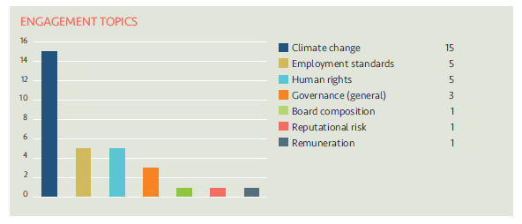
The companies engaged with and the topics raised by LAPFF in Q1 were as follows:

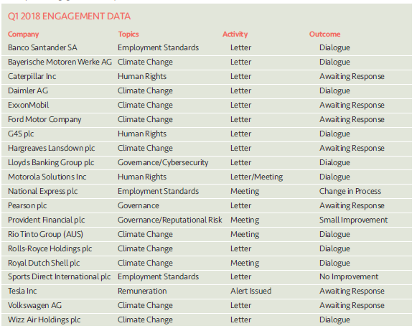
The quarterly statistics show that Climate Change continues to be the issue attracting greatest attention from LAPFF on behalf of member funds.
Climate Action 100+
LPP I has committed to participating in Climate Action 100+. This is a five-year initiative led by investors to engage with the world’s largest corporate greenhouse gas emitters to improve governance on climate change, curb emissions and strengthen climate-related financial disclosures. For the UK and Europe, the initiative is being co-ordinated by the Institutional Investor Group on Climate Change and the PRI and will involve collaborative engagements which bring the resources and concerns of institutional investors together as part of an agreed, organised and common approach.
LPP I is an investor participant and is part of an investor group due to engage collaboratively with Nestle.
Financial Reporting Council (FRC)
The RI Manager met with the FRC in early May to discuss both a recent consultation on the Corporate Governance Code and a forthcoming review of the UK Stewardship Code.
The meeting was between the FRC and members of the LGPS Cross Pool Responsible Investment Group. It reflected joint efforts to establish a good flow of information and a supportive and informed working relationship.
Corporate Governance Code (CGC)
The CGC sets good practice standards for UK listed companies in relation to board leadership and effectiveness, remuneration, accountability and relations with shareholders. Companies are required to report, as part of their annual report and accounts, on how they have applied the main principles of the Code. They must confirm that they have complied with the Code's provisions or – where they have not – provide an explanation. The current version of the code has been in place since 2016.
The FRC confirmed a good response to the consultation which closed on 28th February 2018 (with 231 responses received). The FRC’s intention is for a revised code to be published in July 2018 along with a feedback statement on key features of the consultation responses.
Stewardship Code
The UK Stewardship Code sets out principles for effective stewardship by investors. The Code identifies key areas of good practice to which the FRC believes institutional investors (asset owners, pension fund trustees and their fund managers) should aspire.
LCPF has been reporting on compliance with the Code for several years and the Fund’s latest compliance statement, which reflects the arrangements which have been introduced as part of asset pooling, has been ranked as Tier 1 (highest) by the FRC.
Consultation on the CGC included some initial questions on the Stewardship Code in preparation for the full consultation planned for later this year. The FRC has confirmed that a feedback statement on responses received to these questions will be issued in July, a consultation on a revised Stewardship Code will be published in October 2018 and a final version of the Stewardship Code is planned for Spring 2019.
The FRC welcomed the chance to speak with LGPS representatives as a group and to share thoughts and ideas and encouraged engagement with the consultation process once it begins. Participating in the consultation by feeding back on the proposals will help to shape the new code which will set best practice standards for investors (including LCPF) in performing their stewardship responsibilities going forward.
Shareholder Litigation
LPP I employ Institutional Protection Services (IPS) as an external provider of litigation monitoring services to ensure shareholder litigation cases affecting securities owned by the GEF are known about, claims are filed in a timely way and progress is monitored and followed up with Claims Administrators. In addition, IPS monitor cases relating to shares held by LCPF in the period before the Fund pooled its listed equity investments from November 2016. Litigation can arise quite some time after shares have been sold and monitoring new cases and referring back to historic holdings records to establish rights of ownership is an ongoing task.
IPS provide LPP I with monitoring information on a quarterly basis detailing the number of cases investigated. The monitoring report for Q1 2018 confirms that of 18 potential cases identified where the Fund might have an entitlement to join a class action, further analysis had discounted 10. There are 3 cases where eligibility is still being assessed and 5 where eligibility has been identified and a claim will be filed.

- Active Investing

This section of the RI report is dedicated to updating the Committee on new developments within stewardship and RI and interpreting these within the context of the Fund's responsibilities and interests.

Principles of Responsible Investment (PRI) – 2018 Annual Reporting Round and LGPS Pool Membership

Since the Committee last met, LCPF has submitted annual reporting to the PRI on its activities in the 12 months to 31 December 2017.
A full copy of the submission (in the form of a Transparency Report) will be publicly available from the PRI website later in the Summer but in the meantime a preliminary version can be made available (on request) by the Head of Fund.

The emphasis of detailed annual reporting has continued to become more strongly focussed on practical stewardship activity rather than policy and strategy. This makes it challenging to report and score well when the signatory required to report on activity is LCPF, but practical implementation is delegated to and being undertaken by LPP.

Transition Pathway Initiative (TPI)

LPP is a named supporter of the TPI which is an asset owner-led initiative resourced by the London School of Economics and the Grantham Institute.

Through an online toolkit, TPI share the outcome of analysing (and grading) listed companies within a subset of most exposed sectors on their preparedness for the transition to low carbon. This is based on an assessment of publicly available data. For each company within coverage, the TPI toolkit provides information on:
- the quality of the company’s management of their greenhouse gas emissions and of risks and opportunities related to the low-carbon transition;
- how the company’s future carbon performance (if they publish forward targets) compare to the international targets and national pledges made as part of the Paris Agreement.

The quality of a company’s management of climate change is graded on a scale from 0 to 4 as follows:
Transition Pathway Initiative – Management Quality Scoring

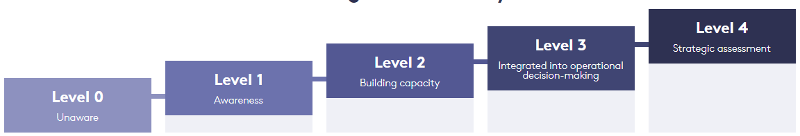

The toolkit provides a helpful reference point for reviewing and comparing the preparedness of listed companies in high-impact sectors (oil and gas, mining and electricity generation, paper, steel, autos, cement) for the risks and opportunities posed by the global transition to lower carbon.

The toolkit is being utilised by LPP I to monitor listed equity investments in the GEF in line with implementing LCPF’s RI Policy commitment not to invest in fossil fuel companies directly engaged in the extraction of coal, oil and natural gas as sources of energy which are ignoring the risks of climate change, and unable to demonstrate planning for future emissions reduction targets under the Paris Agreement.

Companies in the GEF within the coverage of TPI analysis are being monitored on a quarterly basis. Those not judged to be both aware of and building capacity to manage climate change (Level 2 or above) are identified as outliers and trigger a conversation with managers to establish the rationale for holding stock and encourage engagement focussed on improvement.

